Section I: Scenario Demographics

Scenario Title: | Acute Chest Syndrome (Sickle Cell Crisis)
Date of Development: | (DD/MM/YYYY)
Target Learning Group: | Juniors (PGY 1 – 2) Seniors (PGY ≥ 3) All Groups

Section II: Scenario Developers

Scenario Developer(s): | Carla Angleski
Affiliations/Institution(s): | University of Saskatchewan
Contact E-mail (optional): | carla.angelski@icloud.com

Section III: Curriculum Integration

Learning Goals & Objectives
Educational Goal: | To expose learners to an acute chest syndrome in sickle cell disease and review the management of acute chest syndrome.
CRM Objectives: | 1. Allocate resources to ensure child is managed and mom is kept informed and calm.  2. Anticipate and appropriately prepare for the intubation of a child in sickle cell crisis
Medical Objectives: | 1. Recognize acute chest syndrome and modify management accordingly  2. Perform safe intubation of a critically ill child

Case Summary: Brief Summary of Case Progression and Major Events
4-year-old boy with known sick cell disease presents with two days of cough and a one afternoon of fever. Patient is initially saturating at 88%, looks unwell and is in moderate-severe distress. During the case, the patient’s oxygenation with drop and the emergency team is expected to provide airway support. They will also need to pick appropriate induction agents for intubation. The case will end with ICU admission. During the case, the mother will also be challenging/questioning the team until a team member is delegated to help keep the mother calm.

References
Howard et al. (2011). Guideline on the management of Acute Chest Syndrome in Sickle Cell Disease. British Society of Haematology
Marx, J. A., Hockberger, R. S., Walls, R. M., & Adams, J. (2013). Rosen's emergency medicine: Concepts and clinical practice. St. Louis: Mosby.
Section IV: Scenario Script

A. Clinical Vignette: To Read Aloud at Beginning of Case
You are working the day shift at a tertiary children’s hospital. A mother brings in her son, James, a four- year old boy with known sickle cell disease (HbSS). She is concerned since he’s had low energy and a cough for two days. Now he’s had a fever since this afternoon.

B. Scenario Cast & Realism
Patient: | Pediatric Computerized Mannequin |  |  |  |  | Realism:  Select most important dimension(s) |  |  | Conceptual
 | Mannequin |  |  |  |  |  |  |  | Physical
 | Standardized Patient |  |  |  |  |  |  |  | Emotional/Experiential
 | Hybrid |  |  |  |  |  |  |  | Other:
 | Task Trainer |  |  |  |  |  |  |  | N/A
Confederates | Brief Description of Role
Mother | Provide past medical history, behaves in challenging/questioning manner until a specific team member is assigned to keep mother informed and calm
C. Required Monitors
EKG Leads/Wires |  |  | Temperature Probe |  |  |  | Central Venous Line
NIBP Cuff |  |  | Defibrillator Pads |  |  |  | Capnography
Pulse Oximeter |  |  | Arterial Line |  |  |  | Other:
D. Required Equipment
Gloves |  |  | Nasal Prongs |  |  |  | Scalpel
Stethoscope |  |  | Venturi Mask |  |  |  | Tube Thoracostomy Kit
Defibrillator |  |  | PEDS: Non-Rebreather Mask |  |  |  | Cricothyroidotomy Kit
IV Bags/Lines |  |  | Bag Valve Mask |  |  |  | Thoracotomy Kit
IV Push Medications |  |  | Laryngoscope |  |  |  | Central Line Kit
PO Tabs |  |  | Video Assisted Laryngoscope |  |  |  | Arterial Line Kit
Blood Products |  |  | ET Tubes |  |  |  | Other:
Intraosseous Set-up |  |  | LMA |  |  |  | Other:
E. Moulage
Darker skin mannequin wearing t-shirt and shorts.

F. Approximate Timing
Set-Up: |  | 3 min |  | Scenario: | 10 min |  |  | Debriefing: |  | 15 min

Section V: Patient Data and Baseline State

A. Patient Profile and History
Patient Name: James Leroy |  |  |  |  |  | Age: 4 |  |  |  |  |  |  |  | Weight: 22kg
Gender: M F |  |  |  |  |  | Code Status: Full Code
Chief Complaint: Cough X 2 days and fever
History of Presenting Illness: Patient was in usual state of health when he developed a non-productive cough 2 days ago, and a fever earlier today. He has generally been feeling unwell and unable to go to school. Patient is not his usual energetic self according to mom.
Past Medical History: |  | Multiple previous admissions |  |  |  |  | Medications: |  |  |  |  | Prophylactic penicillin
 |  | 2 ICU admissions for chest crisis requiring exchange transfusion |  |  |  |  |  |  |  |  |  | Hydroxyurea (but not taking it consistently due to cost)
 |  | Sepsis X1, Dactylitis X 1, Bony crisis X 5
 |  | Immunizations to date
Allergies: nil
Social History: Family immigrated from Zimbabwe two years ago. Lives at home with parents and 9-year-old sister. James is a student at elementary school.
Family History: Both parents are identified as sickle cell carriers. Sister is a carrier.
Review of Systems: |  | CNS: |  |  | Less energy than usual, but no other specific complaints.
 |  | HEENT: |  |  | Nasal congestion for 2 days
 |  | CVS: |  |  | Normal
 |  | RESP: |  |  | Non-productive cough for 2 days
 |  | GI: |  |  | Normal
 |  | GU: |  |  | Normal
 |  | MSK: |  |  | Normal |  |  |  |  |  |  |  | INT: |  | Normal
B. Baseline Simulator State and Physical Exam
No Monitor Display |  |  |  | Monitor On, no data displayed |  |  |  |  |  |  | Monitor on Standard Display
HR: 130 /min |  |  | BP: 95/25 |  |  |  |  | RR: 30/min |  |  |  |  |  |  | O₂SAT: 88%
Rhythm: regular |  |  | T: 39.5 ºC |  |  |  |  | Glucose: 7.2 mmol/L |  |  |  |  |  |  | GCS: 15 (E 4 V 5 M 6)
General Status: looks unwell, moderate-severe distress
CNS: | Awake and alert
HEENT: | Normal
CVS: | Pulses bilaterally strong, cap refill <2 seconds
RESP: | Diffuse crackles bilaterally with poor air entry to the right
ABDO: | Soft, no distension, no pain on palpation
GU: | Normal
MSK: | No hot/swollen joints. |  |  |  |  |  |  |  | SKIN: | Pale

Section VI: Scenario Progression

Scenario States, Modifiers and Triggers
Patient State | Patient Status | Learner Actions, Modifiers & Triggers to Move to Next State
1. Baseline State  Rhythm:  HR: 130/min  BP: 95/25  RR: 30/min  O₂SAT: 88%  T: 39.5 ºC | Looks unwell, mod-severe distress. Sitting in bed with mom at bedside. Difficulty responding to questions due to SOB. | Learner Actions  - Full history relevant to sickle cell  - Monitors on & apply oxygen  - Airway assessment  - Respiratory & CVS exam  - Obtain IV access  - Blood work (CBC with differential, gas, lytes, BUN, creat, gluc, retics, blood cultures, group and screen)  - IV ABX (ceftriaxone & erythromycin)  - IV fluid NS 10-20cc/kg bolus  - CXR STAT | Modifiers  Changes to patient condition based on learner action  - If mother not addressed (or no team member assigned to her) mother to become agitated & question management  Triggers  For progression to next state  - 3 minutes  2. Deterioration
2. Deterioration  HR 140/min  BP: 85/25  RR: 30/min  O₂SAT: 84% by FM  CVS: CRT 4 seconds | Poor oxygenation despite supplemental O2, mom expressing concern about “the numbers being lower” | Learner Actions  - Reassess airway: suction, reposition head, reapply O2 mask  - Consider high flow O2 for CPAP or BVM with PEEP valve  - Prepare for intubation  - Explain possible intubation need to mom  - Repeat NS bolus 10-20 cc/kg  - Consider ABG | Modifiers  - High flow or BVM with peep O₂SAT to 90%  - No intubation by 6 minutes slowly drop O₂SAT to 80%  Triggers  - Start intubation 3. Intubation
3. Intubation  O₂SAT as per end point of prior state | Same as previous state, sedated and paralyzed once RSI given | Learner Actions  - Preparation/equipment  - Intubates with appropriate induction and paralytic using ETT 5.0 or 5.5 cuffed  (ketamine 1-2mg/kg = 22-44mg, midazolam 0.1mg/kg = 2.2mg, etomidate 0.3mg/kg = 6.6mg, succinylcholine 1.5mg/kg = 33mg, rocuronium 1mg/kg = 22mg)  - Check tube placement with ETCO2, auscultation and CXR | Modifiers  - Drop O₂SAT by 4% during intubation  Triggers  - Intubation  4. Post-Intubation
4. Post-intubation  O₂SAT 94% (increased over 90 seconds) | Give results of blood work at onset of state | - Call ICU if not already done  - Inform mother of progress  - Initiate sedation meds  - Call for PRBC  - Call for exchange transfusion | END CASE PRN

Section VII: Supporting Documents, Laboratory Results, & Multimedia

Laboratory Results
Na: 144 | K: 5 |  | Cl: 102 |  | HCO₃: 16 |  | BUN: 7 |  | Cr: 70 |  | Glu: 6.9
ABG |  | pH: 7.2 |  | PCO₂: 55 |  | PO₂: 84 |  | HCO₃: 16
WBC: 8 |  |  |  | Hg: 62 |  |  |  | Plt: 165

Images (ECGs, CXRs, etc.)
CXR: R-sided infiltrate  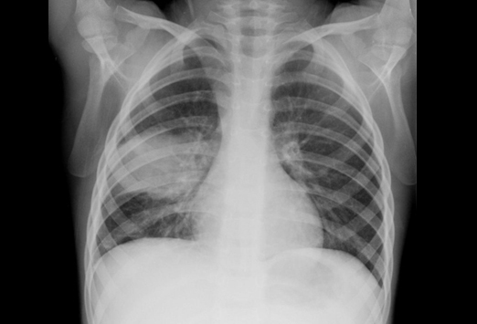  http://reference.medscape.com/features/slideshow/sickle-cell#8 | CXR: post-intubation  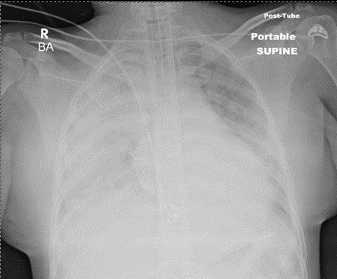  http://www.swjpcc.com/critical-care/?currentPage=4

Section VIII: Debriefing Guide

General Debriefing Plan
Individual | Group |  | With Video | Without Video
Objectives
Educational Goal: |  | To expose learners to an acute chest syndrome in sickle cell disease and review the management of acute chest crisis.
CRM Objectives: |  | 1. Allocate resources to ensure child is managed and mom is kept informed and calm.  2. Anticipate and appropriately prepare for the intubation of a child in sickle cell crisis
Medical Objectives: |  | 1. Recognize acute chest syndrome and modify management accordingly  2. Perform safe intubation of a critically ill child
Sample Questions for Debriefing
- What criteria define an acute chest syndrome?
- When should transfusion be considered in acute chest syndrome?
- How much fluid was given to the child during the case? What is the role for fluid in acute chest syndrome?
- What strategies do you have for addressing parents of critically ill children?
- Do you feel your team communicated well? Did all team members know what was being treated?
- Did everyone feel like they had a clearly defined role? What strategies could be used in the future to ensure roles are clear?
Key Moments
Identification of acute chest syndrome
Identifying need to intubate and safe peri-intubation management
Addressing mom in a calm manner

